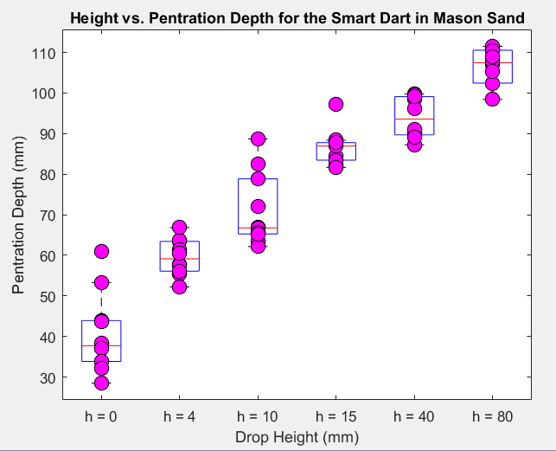

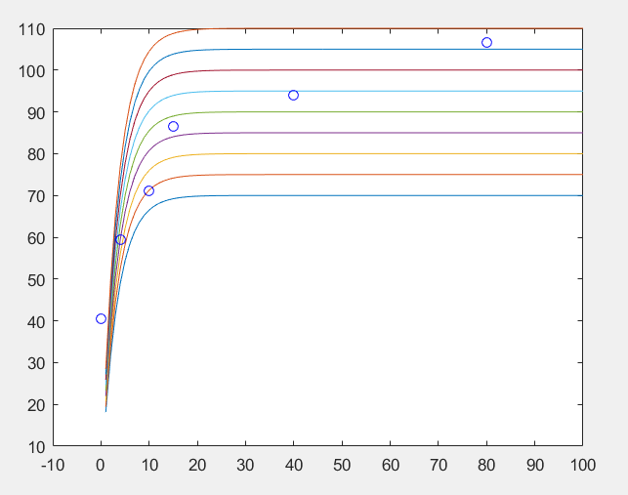

Here I have plotted a group of curves. Should I find the value of A,b variables by trial and error or is there a methodical way to perform the above experiment. Choosing one of these curves would satisfy the required task?

A = 70:5:110

Y = A\*(1-exp(-0.3\*X));